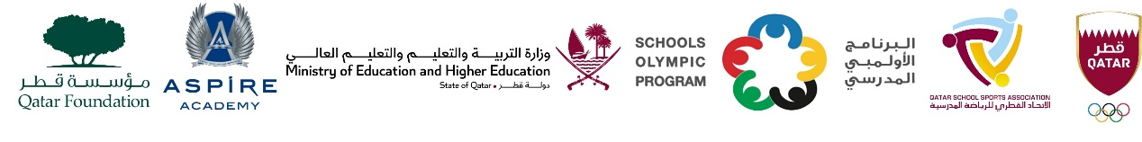

School Olympic Program/ Seventeenth edition
Cricket tournament - Boys Second Level in 2012 – 2013

Boys Second Level – Born in 2012 - 2013
Group A | Group B | Group C | Group D
Al Khor Intl. School (BC) | Pak Shama School | MES Indian School | Birla Public School
TNG Primary & Secondary – Al Wakra | Noble International School | Pakistan Intl. School | DPS Modern Indian School
Ideal Indian School | Al Khor Intl. School (CBSC) | Shantiniketan Indian School | TNG – Ain Khalid
MES Indian School - Abuhamour | - | Bright Future Intl. School | -

