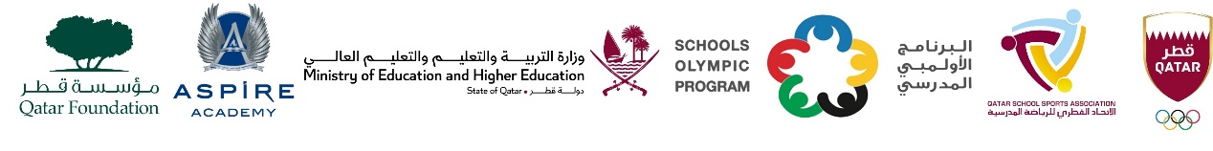

School Olympic Program/ Seventeenth edition
Cricket tournament - Boys Preparatory Level in 2009 – 2010 - 2011

Boys Preparatory Level – Born in 2009 – 2010 - 2011
Group A | Group B | Group C | Group D
DPS Modern Indian School | MES Indian School | TNG Primary & Secondary – Al Wakra | TNG Secondary – Al Wakra
Pak Shama School | Birla Public School | Al Khor Intl. School (CBSC) | Ideal Indian School
Shantiniketan Indian School | Pakistan Intl. School | Noble International School | Stafford Sri Lankan School
Park House English School | Bright Future International School | MES Indian School - Abuhamour | Al Khor Intl. School (BC)

