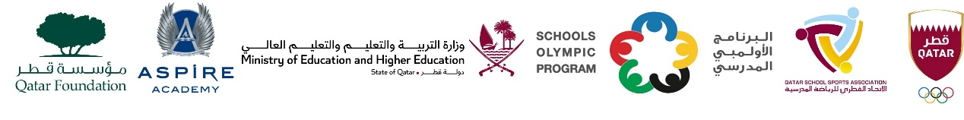

School Olympic Program/ Seventeenth edition
Cricket tournament - Boys Secondary Level , 2006 – 2007 - 2008

Boys Secondary Level – Born in 2006 – 2007 - 2008
Group A | Group B | Group C | Group D
MES Indian School | Park House English School | Pakistan Intl. School | DPS Modern Indian School
Pak Shama School | Birla Public School | TNG Secondary – Al Wakra | Al Khor Intl. School (BC)
Al Khor Intl. School (CBSC) | Ideal Indian School | Noble International School | Stafford Sri Lankan School
Bright Future International School | - | - | -

