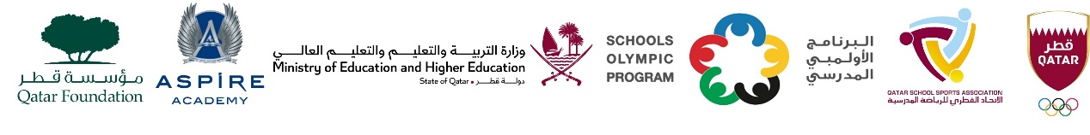
School Olympic Program/ Seventeenth edition
Cricket tournament – Boys Secondary Level , 2006 – 2007 - 2008.
M.No | Day. date | Time | G.N | Teem name | vs | Teem name | Group
1. | Sun,04- Feb-24 | 09:00 AM | WE 1 | Bright Future Intl. School | vs | Al Khor Intl. School (CBSC) | ‘A’
2. | Sun,04- Feb-24 | 09:00 AM | WE 2 | MES Indian School | vs | Pak Shama School | ‘A’
3. | Sun,04- Feb-24 | 09:00 AM | WE 3 | Park House English School | vs | Ideal Indian School | ‘B’
4 | Sun,04- Feb-24 | 10:00 AM | WE 1 | Bright Future Intl. School | vs | Pak Shama School | ‘A’
5 | Sun,04- Feb-24 | 10:00 AM | WE 2 | Al Khor Intl. School (CBSC) | vs | MES Indian School | ‘A’
6 | Sun,04- Feb-24 | 10:00 AM | WE 3 | Birla Public School | vs | Ideal Indian School | ‘B’
7 | Sun,04- Feb-24 | 11:00 AM | WE 1 | Bright Future Intl. School | vs | MES Indian School | ‘A’
8 | Sun,04- Feb-24 | 11:00 AM | WE 2 | Pak Shama School | vs | Al Khor Intl. School (CBSC) | ‘A’
9 | Sun,04- Feb-24 | 11:00 AM | WE 3 | Park House English School | vs | Birla Public School | ‘B’
10 | Mon,5- Jan-24 | 09:00 AM | WE 1 | Pakistan Intl. School | vs | TNG Secondary – Al Wakra | ‘C’
11 | Mon,5- Jan-24 | 09:00 AM | WE 2 | Al Khor Intl. School (BC) | vs | DPS Modern Indian School | ‘D’
12 | Mon,5- Jan-24 | 10:00 AM | WE 1 | TNG Secondary – Al Wakra | vs | Noble Intl. School | ‘C’
13 | Mon,5- Jan-24 | 10:00 AM | WE 2 | Stafford Sri Lankan School | vs | Al Khor Intl. School (BC) | ‘D’
14 | Mon,5- Jan-24 | 11:00 AM | WE 1 | Noble Intl. School | vs | Pakistan Intl. School | ‘C’
15 | Mon,5- Jan-24 | 11:00 AM | WE 2 | Stafford Sri Lankan School | vs | DPS Modern Indian School | ‘D’
16 | TBC | TBC | TBC | Group ‘A’ 1st | vs | Group ‘D’ 1st | Semi - 1
17 | TBC | TBC | TBC | Group ‘B’ 1st | vs | Group ‘C’ 2nd | Semi - 2
18 | TBC | TBC | TBC | SF - 1 Loser | vs | SF – 2 Loser | 3rd Place
19 | TBC | TBC | TBC | SF – 1 Winner | vs | SF – 1 Winner | Final

