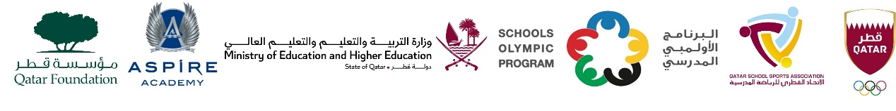

School Olympic Program/ Seventeenth edition
Cricket tournament - Girls Primary Born in 2012 – 2018.

Girls Primary – Born in 2012 to 2018
Group A | Group B
MES Indian School, Doha | TNG Primary & Secondary – Al Wakra
TNG – Ain Khalid | Noble International School
Birla Public School | Al Khor International School CBSC
Shantiniketan Indian School | TNG - Nuaija

