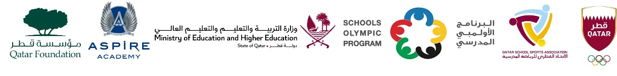

School Olympic Program/ Seventeenth edition
Cricket tournament – Girls Primary Born in 2012 – 2018.
M.No | Day. date | Time | G.No | Teem name | vs | Teem name | Group
1. | Tue,23- Jan-24 | 09:00 AM | WE 1 | MES Indian School, Doha | vs | TNG – Ain Khalid | ‘A’
2. | Tue,23- Jan-24 | 09:00 AM | WE 2 | Birla Public School | vs | Shantiniketan Indian School | ‘A’
3. | Tue,23- Jan-24 | 09:00 AM | WE 3 | TNG Primary & Secondary – Al Wakra | vs | Noble Intl. School | ‘B’
4. | Tue,23- Jan-24 | 09:00 AM | WE 4 | Al Khor Intl. School CBSC | vs | TNG - Nuaija | ‘B’
5 | Tue,23- Jan-24 | 10:00 AM | WE 1 | MES Indian School, Doha | vs | Birla Public School | ‘A’
6 | Tue,23- Jan-24 | 10:00 AM | WE 2 | TNG – Ain Khalid | vs | Shantiniketan Indian School | ‘A’
7 | Tue,23- Jan-24 | 10:00 AM | WE 3 | TNG - Nuaija | vs | Noble Intl. School | ‘B’
8 | Tue,23- Jan-24 | 10:00 AM | WE 4 | TNG Primary & Secondary – Al Wakra | vs | Al Khor Intl. School CBSC | ‘B’
9 | Tue,23- Jan-24 | 11:00 AM | WE 1 | Shantiniketan Indian School | vs | MES Indian School, Doha | ‘A’
10 | Tue,23- Jan-24 | 11:00 AM | WE 2 | TNG – Ain Khalid | vs | Birla Public School | ‘A’
11 | Tue,23- Jan-24 | 11:00 AM | WE 3 | TNG Primary & Secondary – Al Wakra | vs | TNG - Nuaija | ‘B’
12 | Tue,23- Jan-24 | 11:00 AM | WE 4 | Noble Intl School | vs | Al Khor Intl. School CBSC | ‘B’
13 | TBC | TBC | TBC | Group ‘A’ 1st | vs | Group ‘B’ 2nd | Semi - 1
14 | TBC | TBC | TBC | Group ‘B’ 1st | vs | Group ‘A’ 2nd | Semi - 2
15 | TBC | TBC | TBC | SF - 1 Loser | vs | SF – 2 Loser | 3rd Place
16 | TBC | TBC | TBC | SF – 1 Winner | vs | SF – 1 Winner | Final

