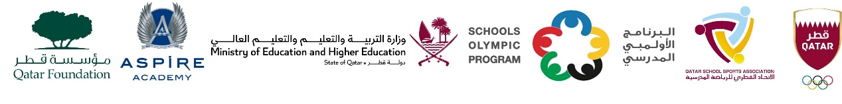

School Olympic Program/ Seventeenth edition
Cricket tournament- Girls Preparatory Born in2009 - 2010 - 2011

Girls Preparatory – Born in 2009 – 2010 - 2011
Group A | Group B
Bright Future International School | Al Khor International School CBSC
TNG Primary & Secondary – Al Wakra | Noble International School
Birla Public School | MES Indian School, Doha
DPS Modern Indian School | Shantiniketan Indian School

