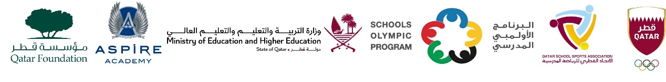

School Olympic Program/ Seventeenth edition
Cricket tournament - Girls Secondary Born in 2006 – 2008

Girls Secondary – Born in 2006 – 2007 - 2008
Group A | Group B
TNG Secondary – Al Wakra. | Bright Future International School
Birla Public School | Al Khor International School CBSC
Noble International School | MES Indian School, Doha
DPS Modern Indian School | -

