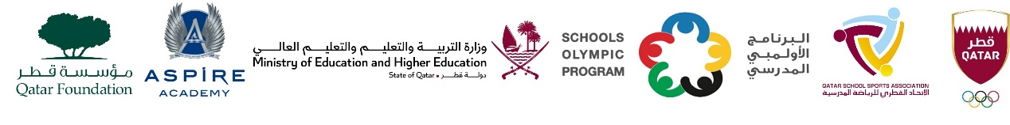

School Olympic Program/ Seventeenth edition
Cricket tournament – Girls Secondary Born in 2006 – 2008
M.No | Day. date | Tim | G.No | Teem name | vs | Teem name | Group
1. | Thu,25- Jan-24 | 09:00 AM | WE 1 | TNG Secondary – Al Wakra. | vs | Birla Public School | ‘A’
2. | Thu,25- Jan-24 | 09:00 AM | WE 2 | DPS Modern Indian School | vs | Noble International School | ‘A’
3. | Thu,25- Jan-24 | 09:00 AM | WE 3 | Al Khor Intl. School CBSC | vs | Bright Future Intl. School | ‘B’
4 | Thu,25- Jan-24 | 10:00 AM | WE 1 | Noble Intl. School | vs | TNG Secondary – Al Wakra. | ‘A’
5 | Thu,25- Jan-24 | 10:00 AM | WE 2 | Birla Public School | vs | DPS Modern Indian School | ‘A’
6 | Thu,25- Jan-24 | 10:00 AM | WE 3 | Al Khor Intl. School CBSC | vs | MES Indian School, Doha | ‘B’
7 | Thu,25- Jan-24 | 11:00 AM | WE 1 | TNG Secondary – Al Wakra. | vs | DPS Modern Indian School | ‘A’
8 | Thu,25- Jan-24 | 11:00 AM | WE 2 | Birla Public School | vs | Noble Intl. School | ‘A’
9 | Thu,25- Jan-24 | 11:00 AM | WE 3 | Bright Future Intl. School | vs | MES Indian School, Doha | ‘B’
10 | TBC | TBC | TBC | Group ‘A’ 1st | vs | Group ‘B’ 2nd | Semi -1
11 | TBC | TBC | TBC | Group ‘B’ 1st | vs | Group ‘A’ 2nd | Semi -2
12 | TBC | TBC | TBC | SF - 1 Loser | vs | SF – 2 Loser | 3rdPlace
13 | TBC | TBC | TBC | SF – 1 Winner | vs | SF – 1 Winner | Final

